WEEK 2 INTERNSHIP REPORT
Advanced Data Visualization and Storytelling with Python: Student Performance Analysis

Internship: Data Science with Python Internship

Dataset: Student Performance Dataset – Mathematics Course
INTRODUCTION:
Data visualization is an important part of data science because it transforms raw data into information that can be understood by both technical and non-technical audiences. Effective visualizations help identify patterns, trends, differences, and relationships that may not be immediately visible in tables or numerical summaries. This project focuses on advanced data visualization and storytelling using Python. The aim was to explore student academic performance and communicate meaningful findings through a sequence of visualizations. Rather than examining individual variables in isolation, the analysis was organized as a data story that investigates overall academic performance and then explores factors that may be associated with differences in student outcomes.
The Student Performance dataset was used for this analysis. It contains information about students' demographic characteristics, family background, study habits, attendance, previous academic failures, and grades. Data from both Mathematics and Portuguese courses were used to provide a broader comparison of student performance across subjects. Python libraries including Pandas, Matplotlib, and NumPy were used to prepare the data and create the visualizations. The findings provide insights into academic performance patterns and potential factors that could be considered for further statistical and machine learning analysis..

DATASET AND METHODOLOGY:
The analysis used the publicly available Student Performance dataset, which contains two related datasets: student performance in Mathematics and student performance in Portuguese. The Mathematics dataset contains 395 student records, while the Portuguese dataset contains 649 student records. Both datasets contain information about student demographics, family characteristics, educational background, study habits, lifestyle factors, absences, and academic grades. A subject column was added to each dataset before combining them. The Mathematics and Portuguese datasets were then combined into a single dataset containing 1,044 records. The visualizations were developed using Matplotlib. Grouping and aggregation operations were performed using Pandas to calculate average final grades across relevant categories. The analysis focused primarily on the final grade variable, G3, as the main indicator of academic performance.
Code snippet used for loading and combining the data:
import pandas as pd
import matplotlib.pyplot as plt
mat_df = pd.read_csv("student_data/extracted/student-mat.csv", sep=";")
por_df = pd.read_csv("student_data/extracted/student-por.csv", sep=";")
mat_df["subject"] = "Mathematics"
por_df["subject"] = "Portuguese"
df = pd.concat([mat_df, por_df], ignore_index=True)
print("Mathematics dataset shape:", mat_df.shape)
print("Portuguese dataset shape:", por_df.shape)
print("Combined dataset shape:", df.shape)
df.head()

DATA VISUALIZATION AND STORYTELLING:

Visualization 1: Distribution of Final Grades by Subject
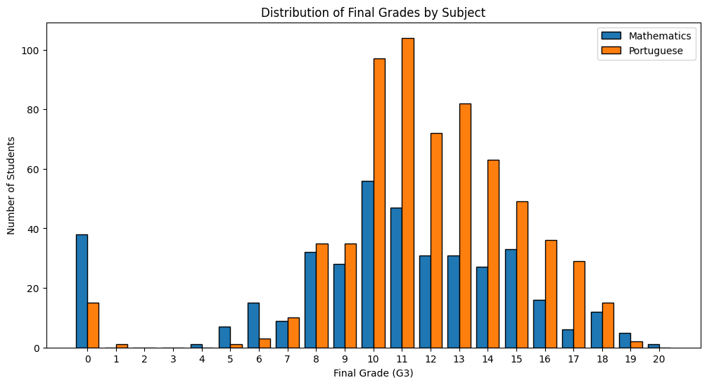

Purpose of the Visualization
The first visualization compares the distribution of final grades for students studying Mathematics and Portuguese. A grouped bar chart was selected instead of overlapping histograms to make the comparison between subjects clearer for a non-technical audience. Each final grade is represented separately for the two subjects.

Insight
The visualization provides an overview of how student performance is distributed across the two subjects. It shows the concentration of students at different final-grade levels and makes it possible to identify differences in the frequency of low, medium, and high grades. This establishes the starting point for the overall data story by showing the academic performance patterns before examining possible factors associated with those outcomes.

Contribution to the Data Story
This visualization answers the first question of the analysis: How does overall student performance differ between Mathematics and Portuguese? The remaining visualizations build upon this overall picture by investigating study habits, attendance, academic history, correlations, and family background.
- Visualization 2: Average Final Grade by Weekly Study Time
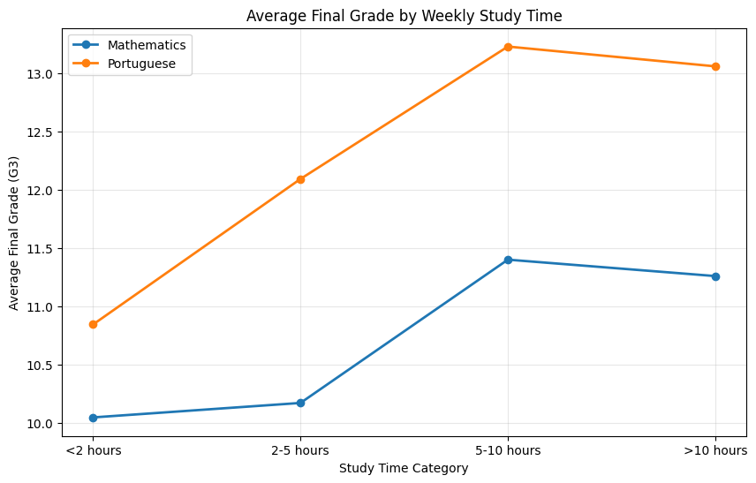

Purpose of the Visualization
The second visualization examines the relationship between weekly study time and average final grades. A line chart was used to show how average academic performance changes across the different study-time categories for both subjects.

Insight
The results show that academic performance varies across study-time categories. Students who reported different amounts of weekly study time did not all achieve the same average final grade, indicating that study time may be associated with academic performance but is unlikely to be the only factor influencing student outcomes. The comparison between Mathematics and Portuguese also shows whether this pattern is similar across subjects.

Contribution to the Data Story
After establishing overall performance patterns, this visualization investigates a potential behavioural factor: Does the amount of time spent studying relate to academic performance?

Visualization 3: Average Final Grade by Number of Absences
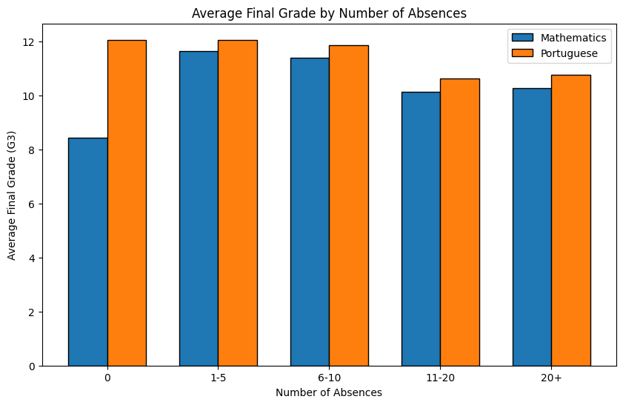

Purpose of the Visualization
This visualization explores the relationship between student attendance and academic performance. Students were grouped according to their number of absences, and the average final grade was calculated for each absence group. A grouped bar chart was selected to allow a clear comparison between Mathematics and Portuguese without overlapping data points.

Insight
The chart demonstrates that average academic performance differs across absence categories. This suggests that attendance may be related to student outcomes. However, the pattern should be interpreted carefully because absences alone cannot explain all differences in final grades. Other academic, personal, and social factors may also contribute to performance.

Contribution to the Data Story
This visualization shifts the analysis from study behaviour to attendance and asks: Is student attendance associated with academic outcomes?

Visualization 4: Correlation Heatmap of Academic Factors
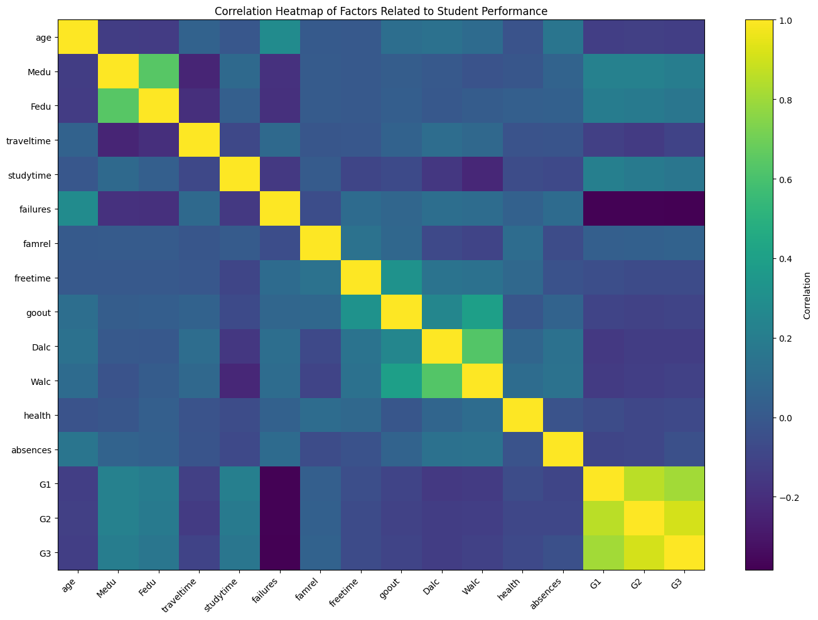

Purpose of the Visualization
The correlation heatmap was created to examine relationships among important numerical variables in the dataset. Correlation values help identify whether two variables tend to increase together, decrease in opposite directions, or show little linear relationship. This visualization provides a broader overview of the factors connected with student performance.

Insight
The heatmap highlights the relationships between previous grades (G1 and G2) and the final grade (G3). These variables show a strong positive relationship, suggesting that earlier academic performance is closely associated with final outcomes. Previous failures show a negative relationship with academic performance. Other variables, such as study time, absences, and lifestyle-related factors, show weaker or varying relationships.

Contribution to the Data Story
This visualization expands the analysis beyond individual factors and answers the question: Which variables appear to have the strongest relationships with academic performance?

Visualization 5: Average Final Grade by Number of Previous Failures
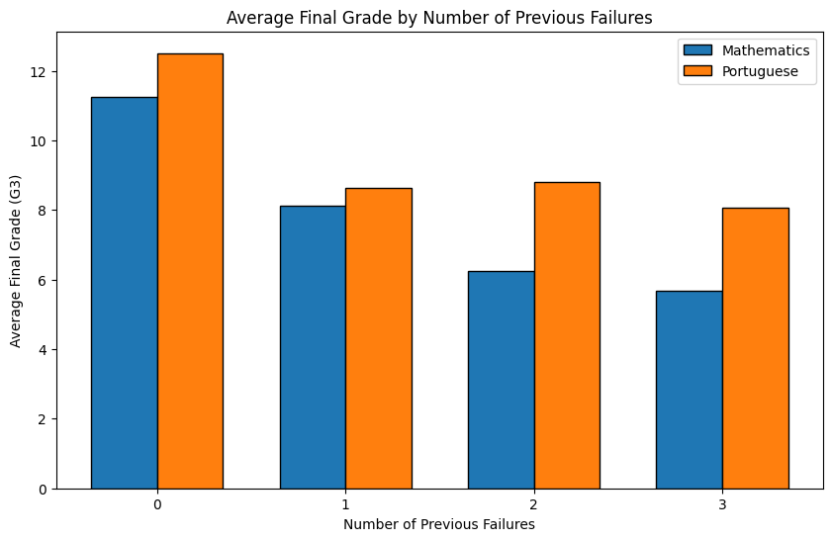

Purpose of the Visualization
This visualization examines the relationship between a student's previous academic failures and current final performance. The average final grade was calculated for each category of previous failures and compared between Mathematics and Portuguese using a grouped bar chart.

Insight
The visualization indicates that students with a history of more previous failures generally tend to have lower average final grades. This pattern suggests that previous academic difficulties may be an important indicator of future academic performance. The comparison between the two subjects also helps determine whether this relationship is consistent across different academic areas.

Contribution to the Data Story
This part of the analysis focuses on academic history and asks: Does previous academic difficulty relate to current student performance?

Visualization 6: Average Final Grade by Mother's Education Level

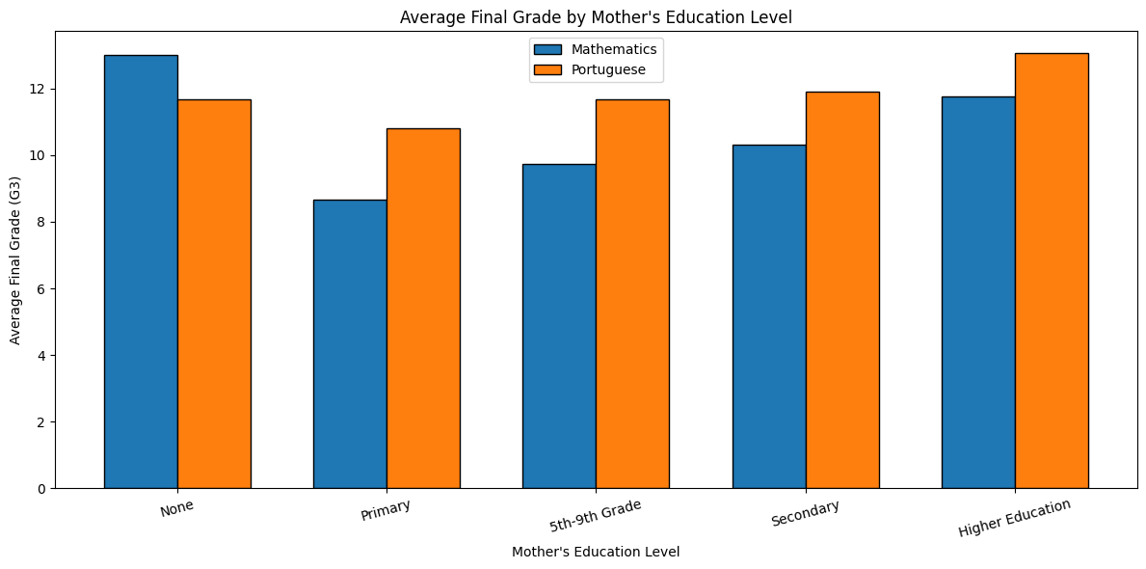

Purpose of the Visualization
The final visualization explores the relationship between family educational background and student performance. Mother's education level was selected as an indicator of family background, and average final grades were compared across different education categories for Mathematics and Portuguese.

Insight
The visualization shows that average student performance varies across different levels of maternal education. This may suggest an association between family educational background and academic outcomes. However, this visualization does not prove that a mother's education level directly causes differences in student performance, since many other social, economic, and personal factors may also influence academic achievement.

Contribution to the Data Story
This visualization adds a broader social perspective to the analysis by asking: Does family educational background show a pattern in student academic performance?

OVERALL DATA STORY:
The visual analysis presents a progressive story about student academic performance. The analysis begins by comparing the overall distribution of final grades in Mathematics and Portuguese, providing a general picture of student outcomes across the two subjects. The next stage examines student behaviour and academic habits. Study time provides insight into whether the amount of time dedicated to studying is associated with differences in average performance. Attendance is then explored through the relationship between absences and final grades, highlighting another factor that may influence academic outcomes. The correlation heatmap provides a broader view by examining relationships among several numerical variables simultaneously. Previous grades show a particularly strong association with final grades, while previous academic failures demonstrate a negative relationship with performance.
Finally, the analysis considers previous academic history and family educational background. The visualizations suggest that students' current performance may be associated with multiple interconnected factors rather than a single variable. Overall, the data story moves from general performance patterns toward behavioural, academic, and social factors that may help explain differences in student outcomes.
POTENTIAL EDUCATIONAL AND SCIENTIFIC IMPLICATIONS:
The findings from this analysis have potential implications for educational institutions, teachers, and researchers. The visual patterns suggest that previous academic performance and previous failures could help identify students who may require additional academic support.Attendance patterns may also be useful for monitoring student engagement. Students with consistently high numbers of absences could be examined further to determine whether they require intervention or additional support.
The analysis also shows that student performance is a multidimensional issue. Study habits, academic history, attendance, and family background may all contribute to differences in educational outcomes. Therefore, educational decisions should avoid relying on a single factor when evaluating student performance. From a scientific perspective, the visualizations provide useful starting points for further investigation. The observed patterns could be tested using statistical hypothesis testing in the next stage of the project. Machine learning models could also be developed later to predict student performance using relevant demographic, behavioural, and academic variables.

CONCLUSION:
This Week 2 project demonstrated how Python can be used to transform student data into a clear and meaningful visual narrative. Six visualizations were developed using Pandas, NumPy, and Matplotlib to explore different aspects of student academic performance.The analysis compared performance between Mathematics and Portuguese and examined the relationships between final grades and factors such as study time, absences, previous academic failures, previous grades, and family educational background. The correlation analysis showed that earlier grades were strongly associated with final academic outcomes, while previous failures showed a negative relationship with performance.
Overall, the visualizations demonstrate that academic performance is influenced by multiple factors. The results provide a useful foundation for more rigorous statistical testing and predictive modelling in the later stages of the data science project.

